**Installation to be done for Session 8**

1. **Install SQL Server Express Edition**
2. Open file: SQL2019-SSEI-Expr.exe
3. Start the installation, select Yes if prompted.
4. Select the Installation type: Basic

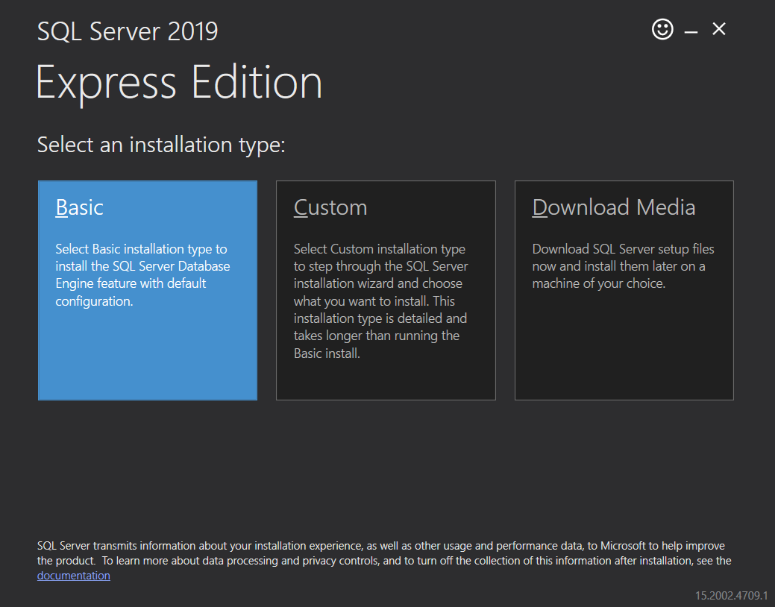

1. Click Accept Button.

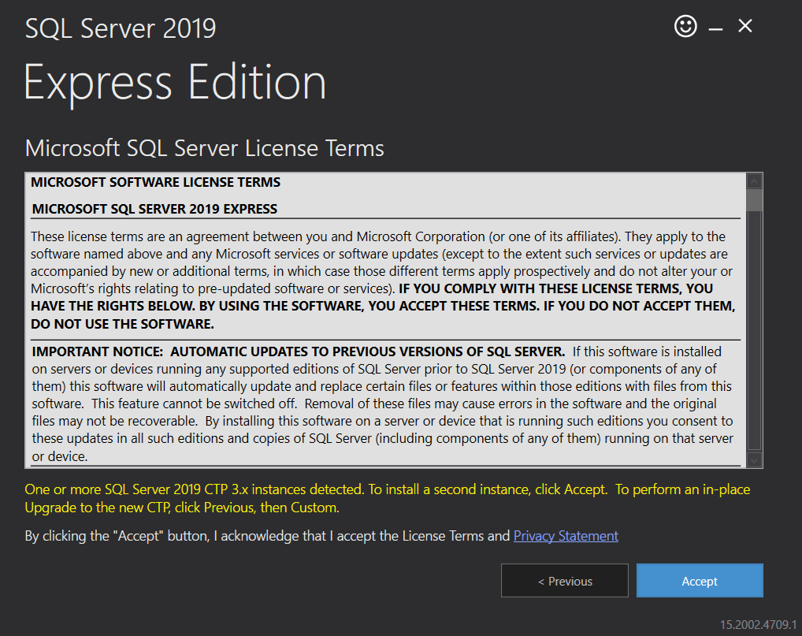

1. Click Install Button.

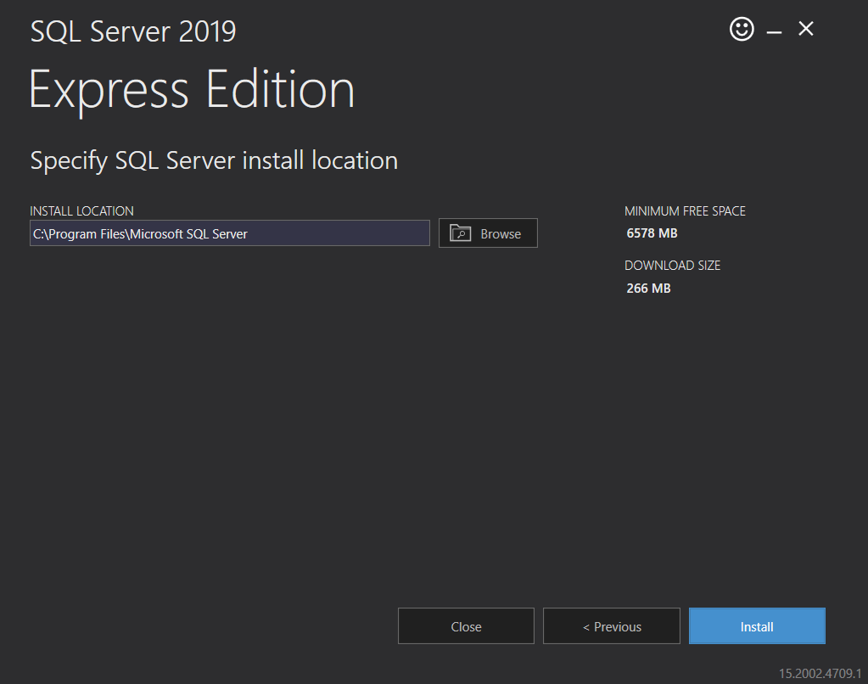

1. Next step will download and install the software, so wait for some time.
2. Installation Done.

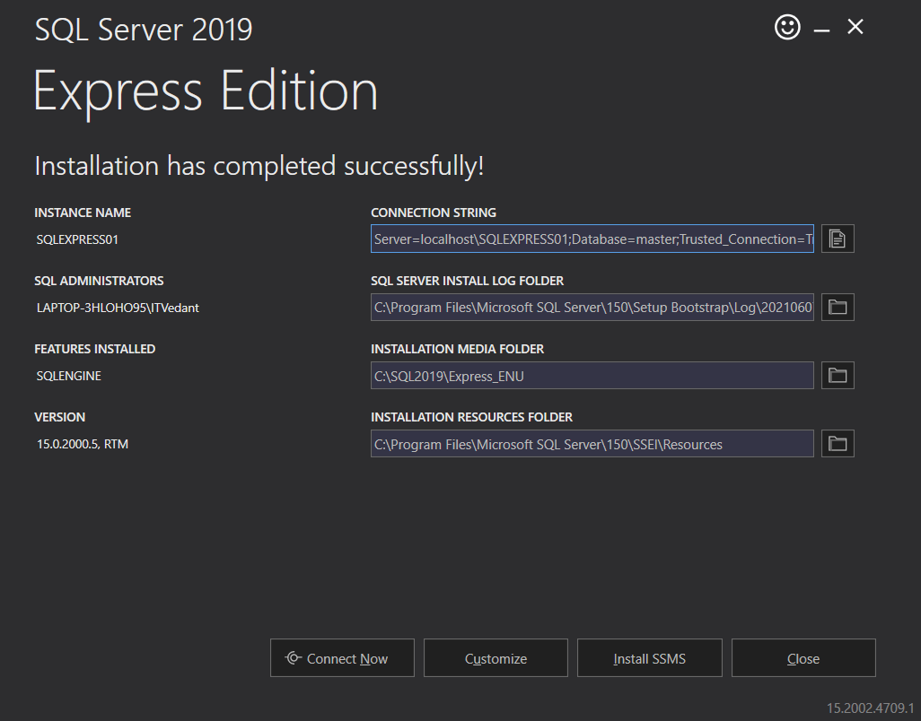

1. Close the installer.
2. **Install Microsoft SQL Management Studio**
3. Open file: SSMS-Setup-ENU.exe
4. Start the installation, select Yes id prompted.
5. Click Install Button.

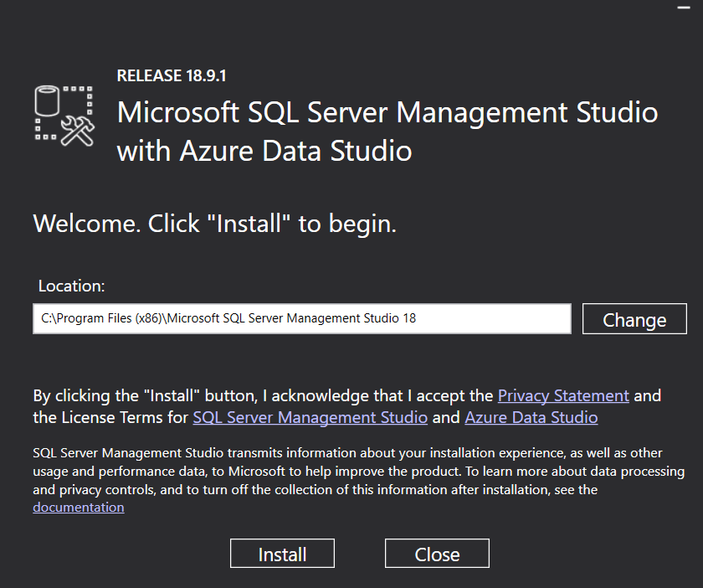

1. If prompted for restart of the system, restart the system and start the installation again.
2. Installation done.

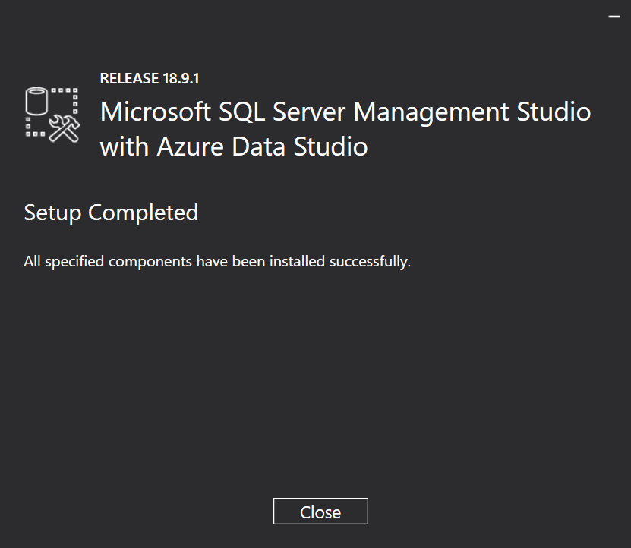

1. Close the installer.
2. **Install Power BI Report Server**
3. Open file: PowerBIReportServer.exe
4. Select the PowerBIReportServer.exe to download.
5. Start the installation.
6. Select Install Power BI Report Server.

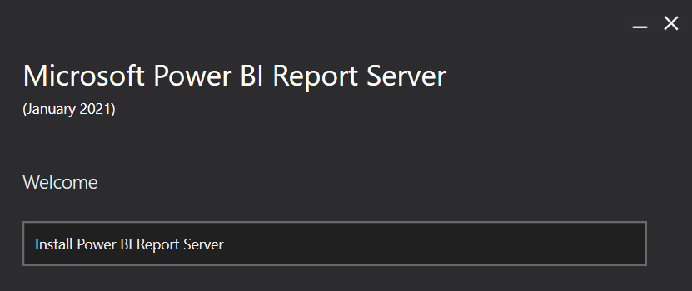

1. Select Choose a free edition, Click Next.

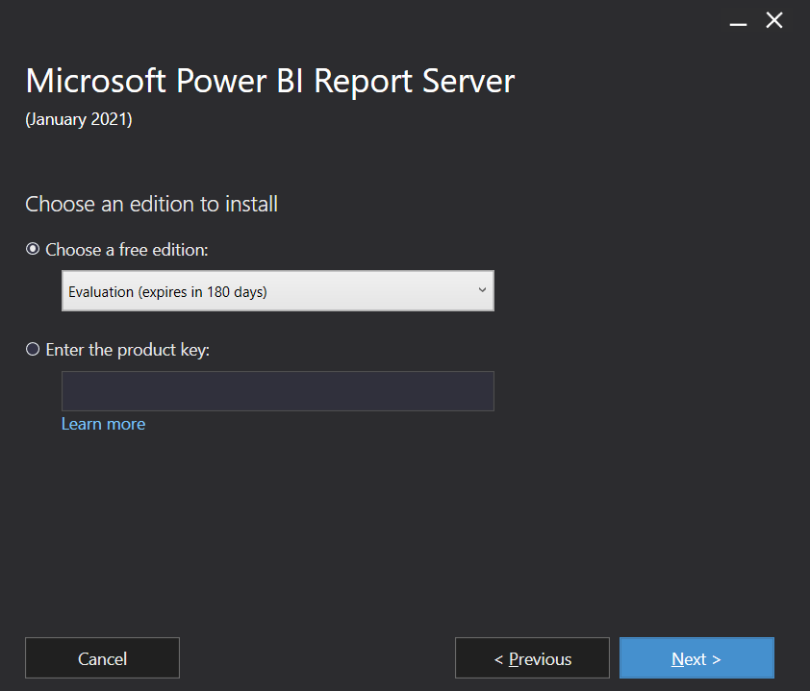

1. Select the I accept the license terms checkbox, Click Next.

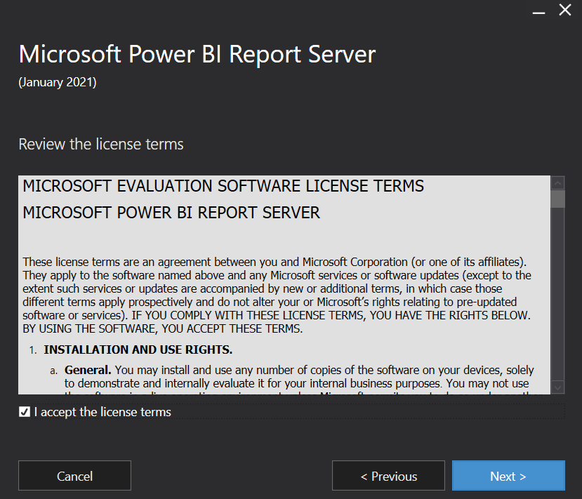

1. Select Next.

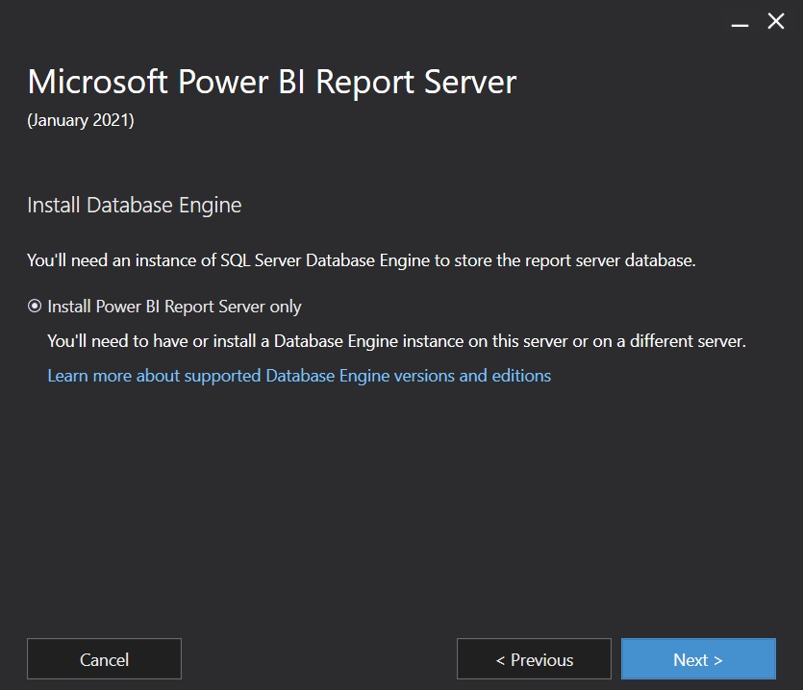

1. Select Install.

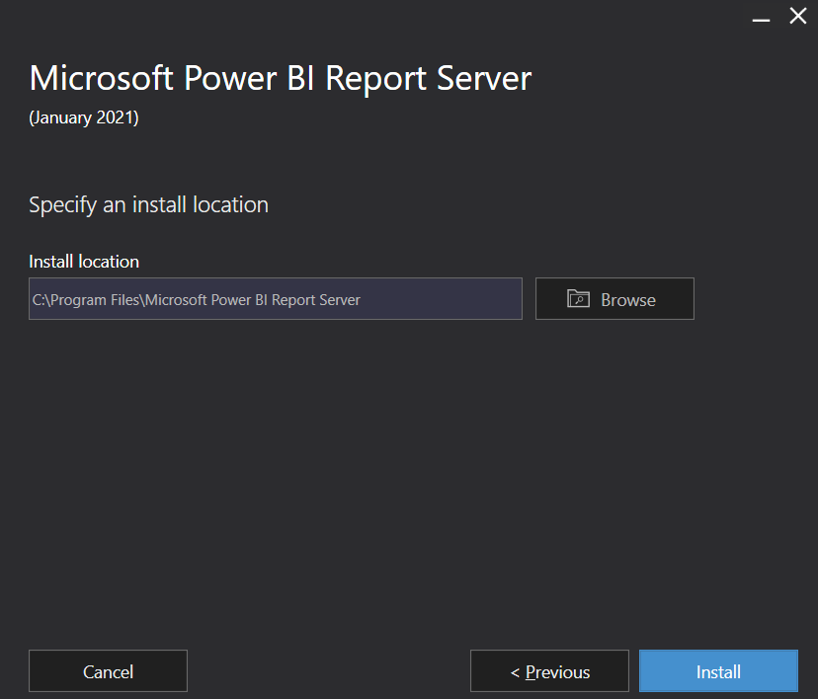

1. If prompted, select Yes.
2. Select Restart.

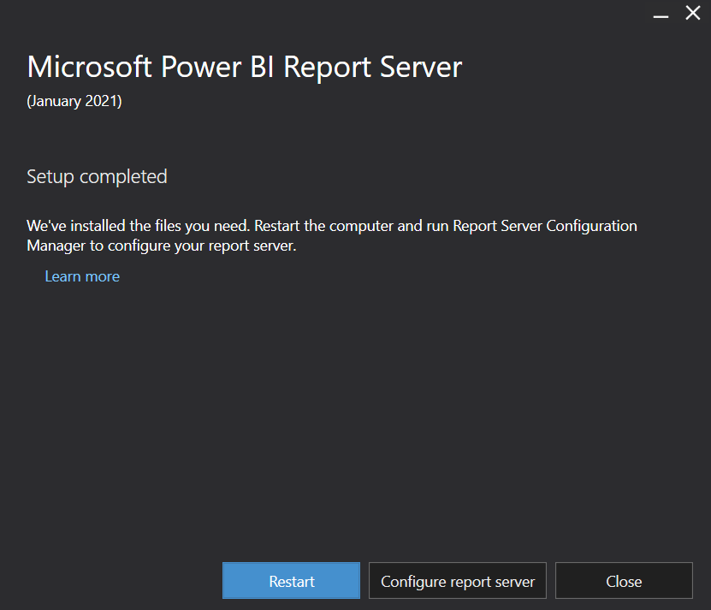

1. **Install Power BI Desktop for Report Server**
2. Open file: PBIDesktopRS_x64.msi
3. Select PBIDesktopRS_x64.msi file to download.
4. Start the installation.
5. Select Next.

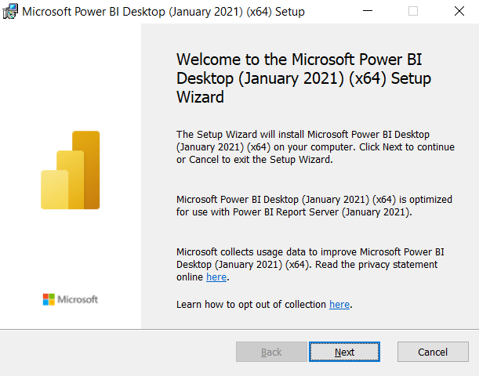

1. Select I accept the terms in the License Agreement checkbox, and select Next.
2. Select Next.
3. Select Install.
4. If prompted, select Yes.
5. Select Finish.
6. **Install Microsoft Report Builder**
7. Open file: ReportBuilder.msi
8. Start the installation.
9. Select Next.

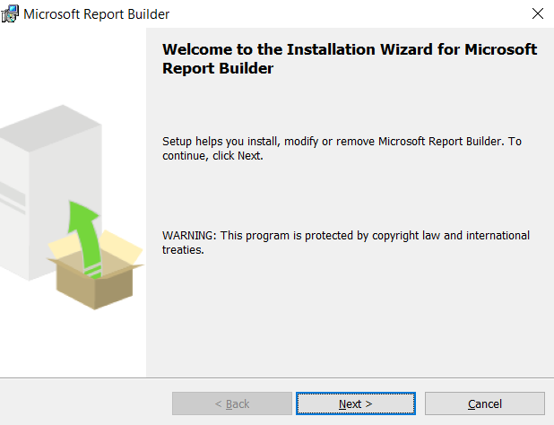

1. Select I accept the terms in the License Agreement radio-button, and select Next.
2. Select Next.
3. Select Next.
4. Select Install.
5. If prompted, select Yes.
6. Select Finish.